Tableau Instructions: Using Tableau To Map Information On Nursing Homes In Your State.
By Long Term Care Community Coalition

Downloading Tableau (instructions via chadskelton.com/p/installing-tableau-public-and-open.html):
1. Visit https://public.tableau.com/en-us/s/download, enter email, select DOWNLOAD THE APP.

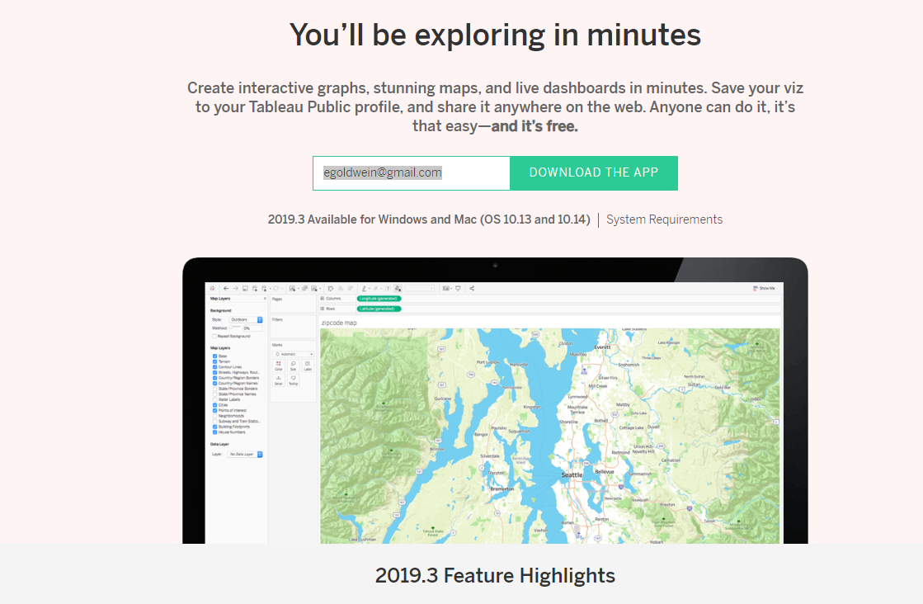
2. After file has been downloaded, run it and follow the prompts to install Tableau on your Mac or PC.

- On a PC, Tableau Public shortcut should be visible on your desktop. Double click it and
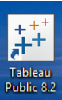

PC Tableau icon

- On Mac, you may have to search for Tableau by double clicking search icon in the top right and typing in 'tableau'. Next, drag the program into your dock and double click icon to load Tableau Public. Your screen should look like this:

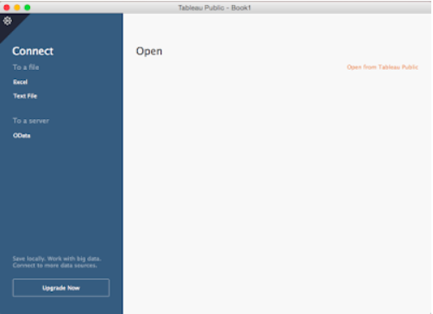

- Getting Started
  - Open Tableau Public. Select Microsoft Excel on top left to add files. Select Conference.US NH ratings&SFF.xlsx.
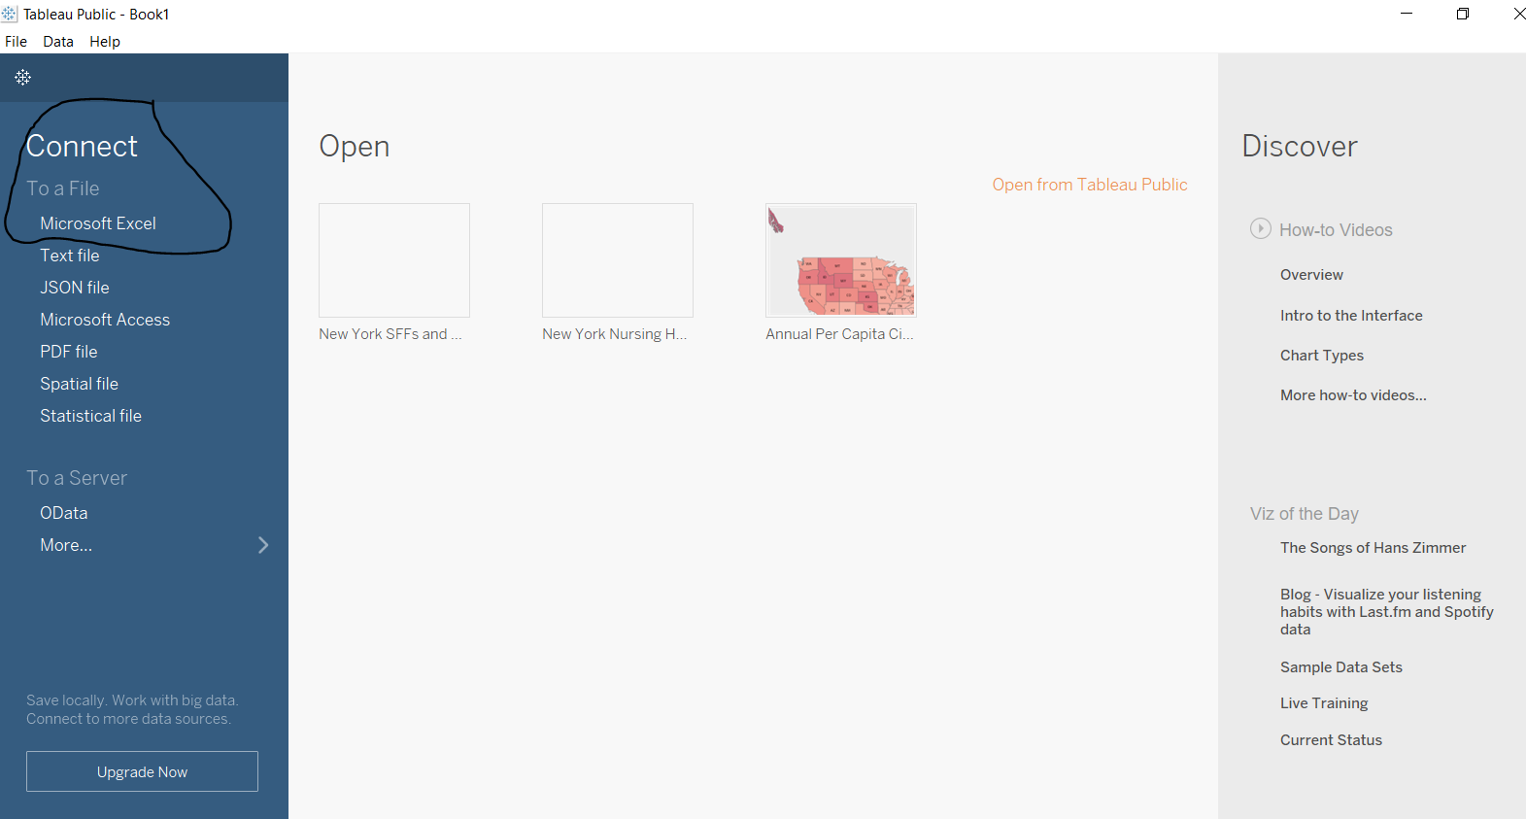
  - Excel files should include latitude, longitude, and variables of interest (ie. Overall rating, Provider name, etc). 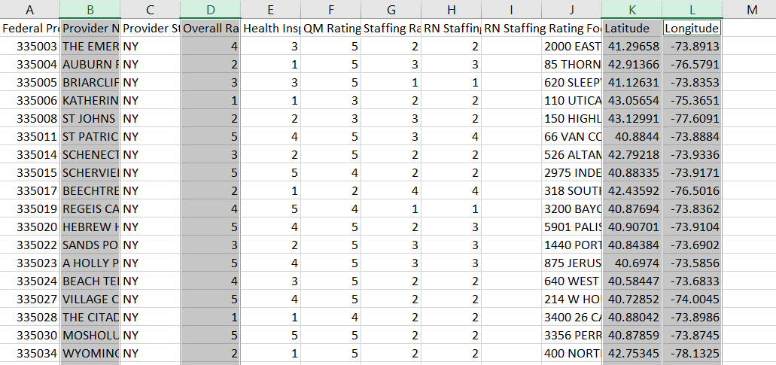
    - Note: Excel file should be checked for errors, missing datapoints, outliers, etc.
  - Click Sheet 1 on bottom left, then right click Sheet 1 to rename (i.e. New York Nursing Home Ratings)
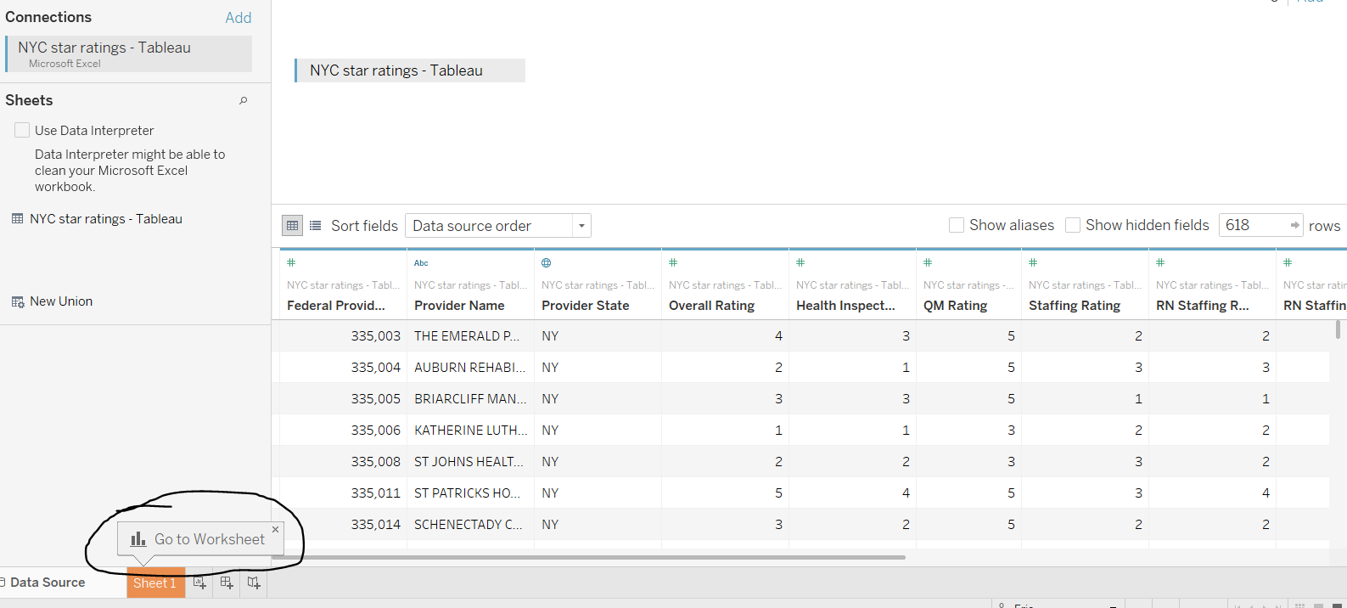

- Creating Datapoints
  - On the left column there are two sections: 1) Dimensions and 2) Measures.
  - Under Dimensions, select Provider State and drag into Filters shelf. Select state(s) of interest.
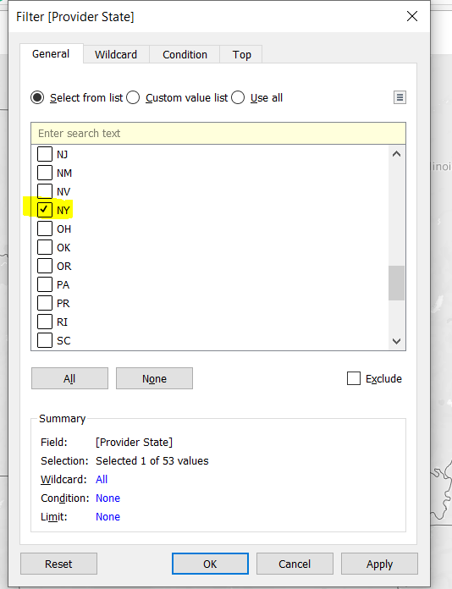
Filtered by state (NY)
  - Under Measures, find items labeled “Latitude” and “Longitude. Do NOT use items labeled “Latitude (generated)” and “Longitude (generated)”. Drag Longitude to Columns on shelf on top of map. Drag Latitude to Rows (below Columns).
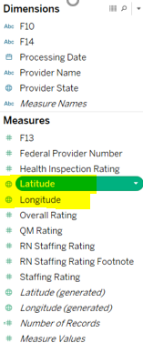
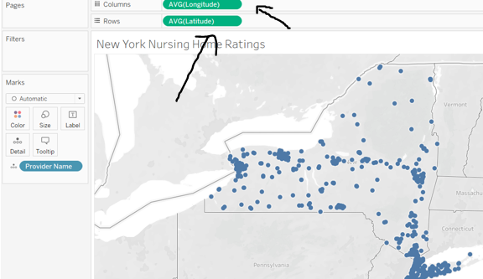

  - Under Dimensions, select Provider Name and drag into Detail in the shelf labeled Marks. The map will now display your state’s nursing homes and locations.
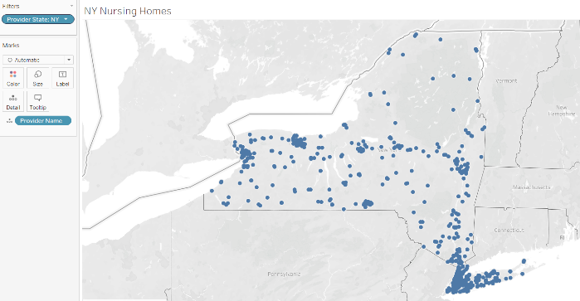
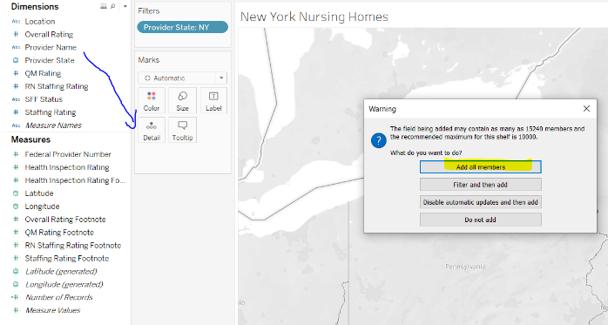
New York nursing home locations

- Illustrating Overall Ratings (by Color)
  - Under Measures and Dimensions, identify variable(s) of interest: Overall Rating, Health Inspection Rating, QM Rating, Staffing Rating.
    - Drag variables of interest from Measures to Dimensions.
  - To illustrate overall ratings by color, drag Overall Rating to Color (found in Marks shelf).

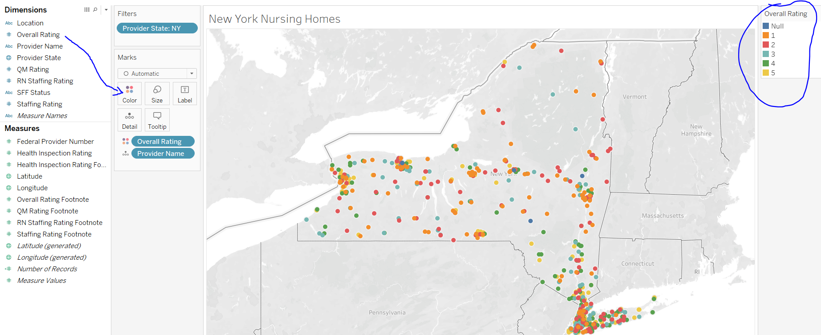
    - Edit Colors and Legend title by hovering over Overall Rating on top right and selecting arrow.
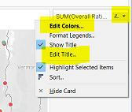

    - Edit colors manually by assigning colors to each number or automatically assign colors by selecting Tableau’s Color Palettes.
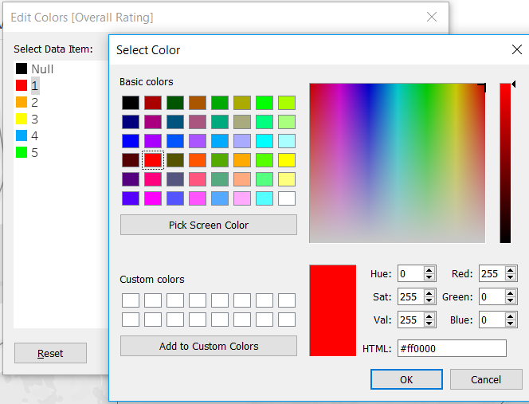
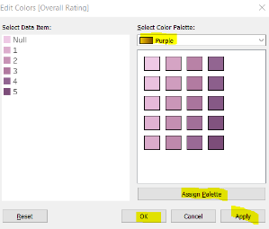

Manual color assignment (left) vs. Tableau color palette (right)
  - Rename values in Legend by right clicking value and selecting Edit Alias.

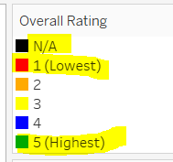
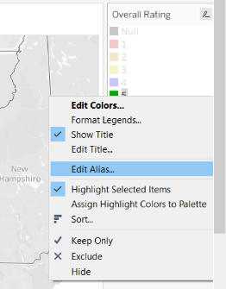
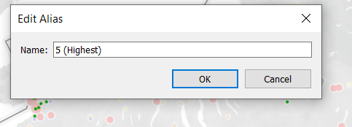
Alias changed from "5" to "5 (Highest)"

- Illustrating Special Focus Facility (SFF) status (by Size)
  - Under Dimensions, drag SFF Status to Size (found in Marks shelf).
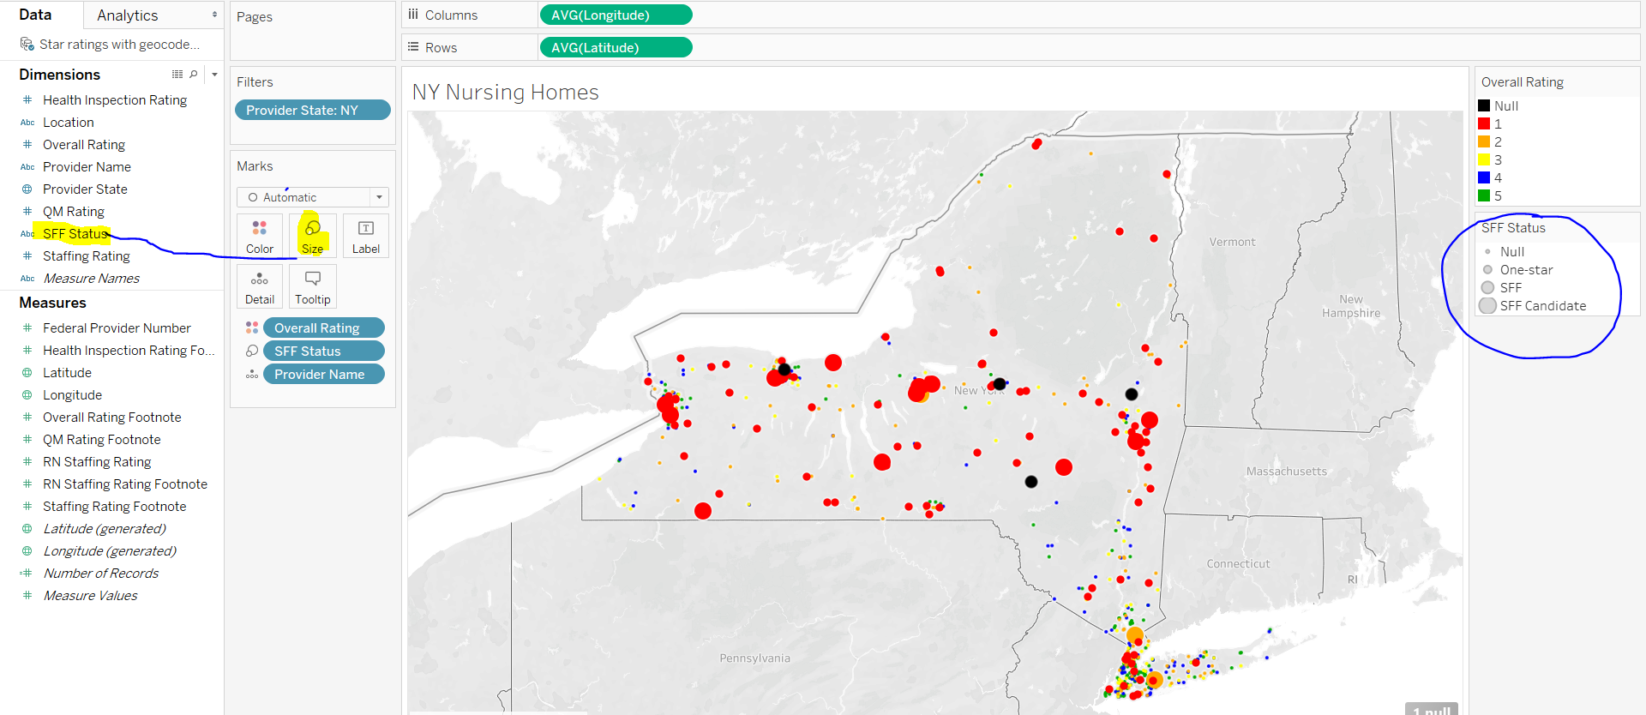

  - To edit legend (title, sizes), hover over SFF Status on top right and select arrow.
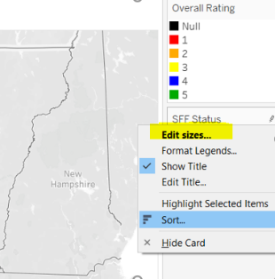

    - To re-order Legend, select Manual and adjust items by preferred order.
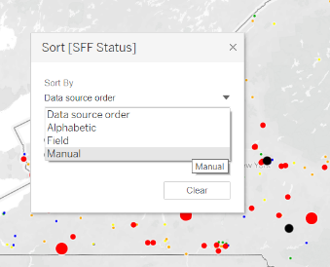

    - To resize circles, select Edit sizes… and toggle Mark size range. 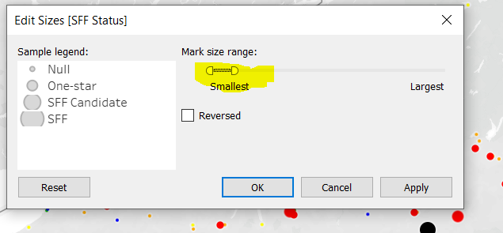

- Secondary Variables
  - Under dimensions, identify secondary variables of interest (QM Rating, Staffing Rating, Health Inspection Rating). Select variables and drag to Marks under Details.
    - When hovering over a nursing home, you will now see primary and secondary variables.
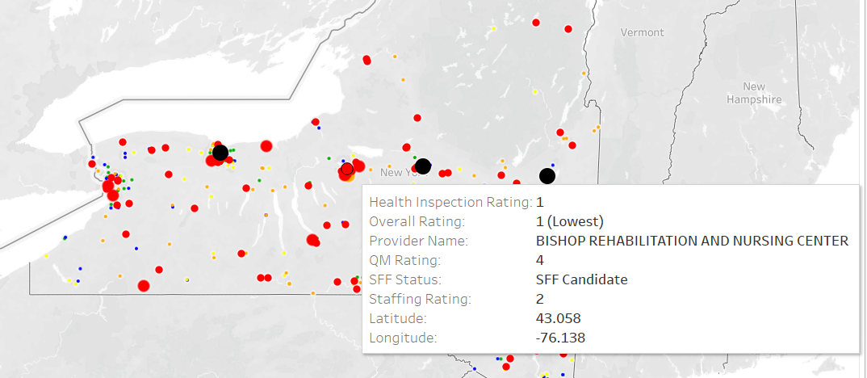
Unedited Tooltip

    - To edit hover display, select Tooltip under Marks. Here, you can delete unwanted fields (Latitude and Longitude) and rearrange items (Moving up Provider Name, SFF Status, Overall Ratings).

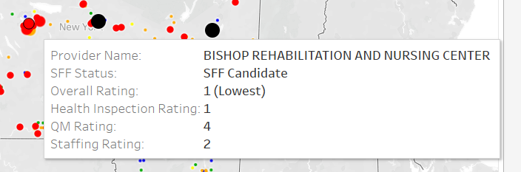
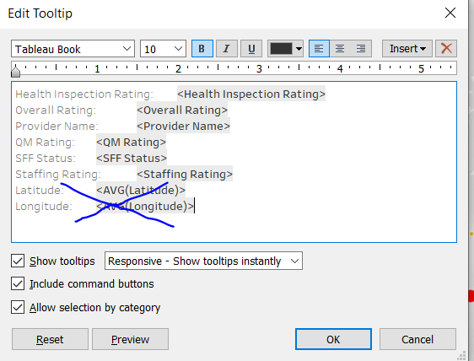
Updated Tooltip

- Finishing touches
  - Map Layers
    - Go to Map Map Layers. Under Map Layers, select desired items (county names, county borders).
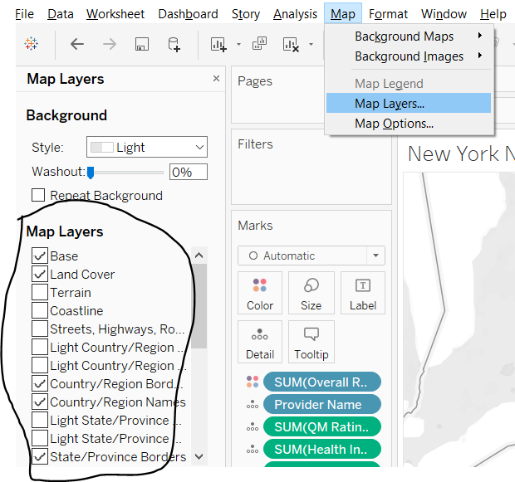
  - Data Layers
    - Go to Map Map Layers Data Layers (scroll down). Under Data Layers, select desired demographic and boundary.
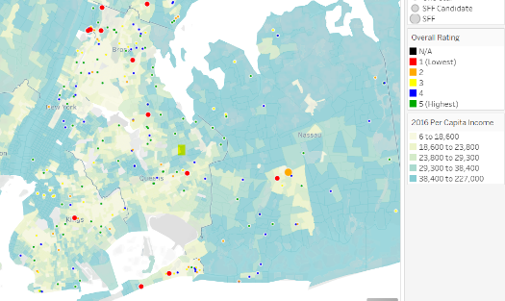
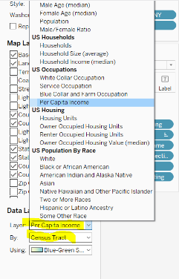
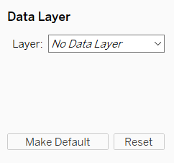

New York City Per Capita Income (By Census Tract)

  - Title. Double click title area to adjust size, font, text, etc.
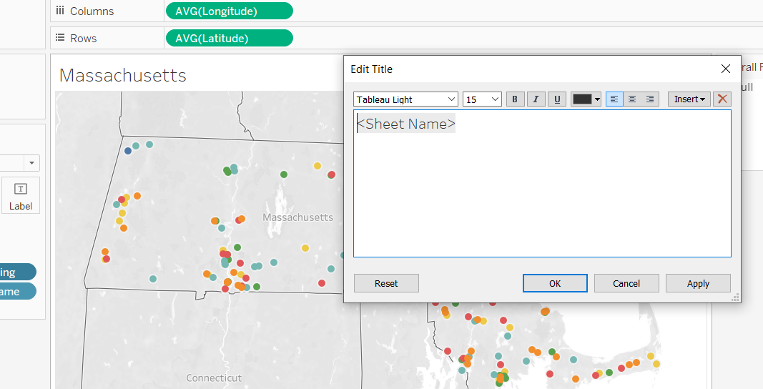

  - Search boxes.
To add a search box for facility, click arrow next to “Provider Name” and select Show Filter. A list will appear to the right of the map; click dropdown arrow and select Single Value (dropdown) and then select Only Relevant Values to capture New York nursing homes. Now a dropdown menu should appear. Select (All) to show all facilities.
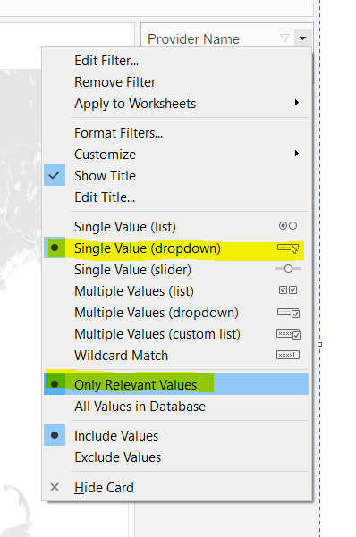
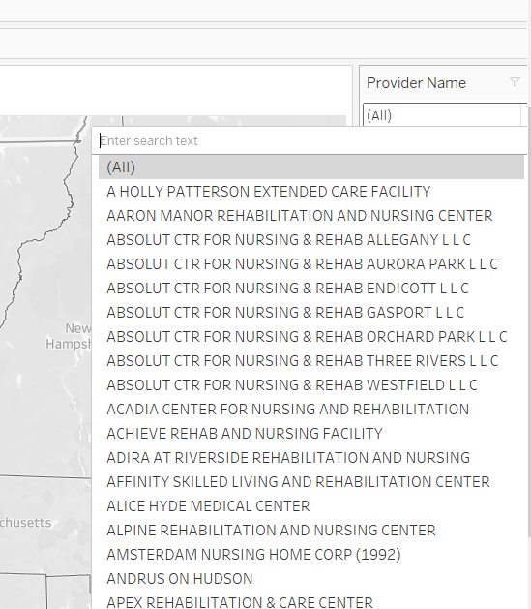
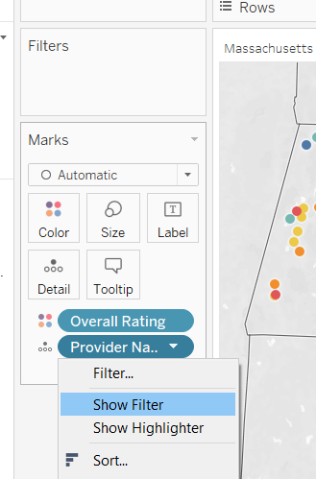
Dropdown list includes all 618 New York nursing homes

- Publishing and embedding
  - File Save to Tableau Public. Once map is online, select share button on bottom right to find hyperlink and embed code.
