Data Entry: Instructions On How To Download Data From Nursing Home Compare And Set It Up For Mapping On Tableau.
By Long Term Care Community Coalition

- Downloading Data
  - Visit https://data.medicare.gov, scroll down, and select “Nursing Home Compare data” 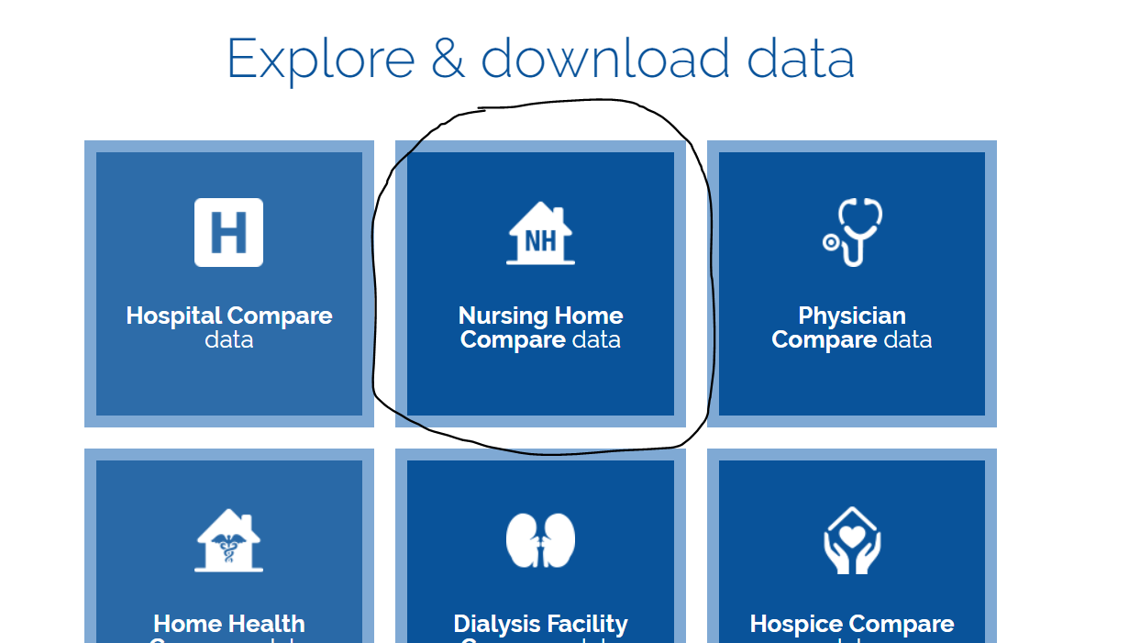
  - Use search function to find dataset of interest – in this case, “Star Ratings.”
  - Select Star Ratings and use the “Filter” feature to select data of interest.
    - In this example, select the arrow next to Federal Provider Number and select “Provider State.” Type “MA” check small square next to text box.
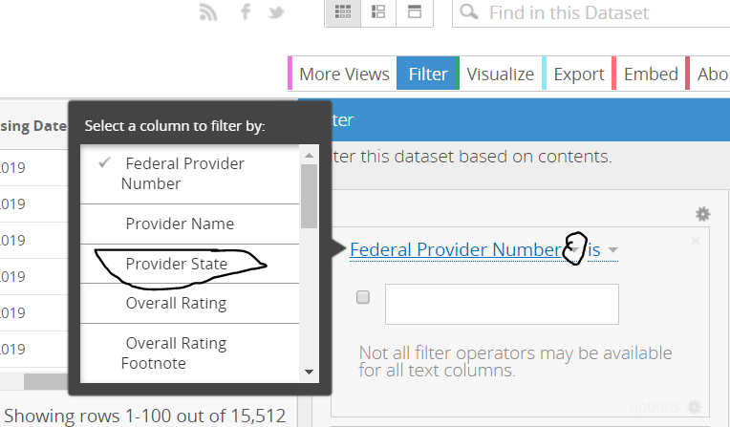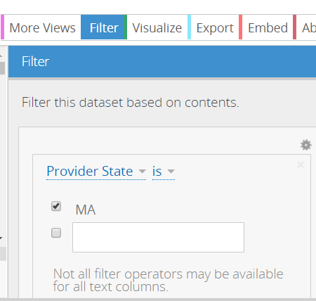
  - To download file, select Export Download CSV.
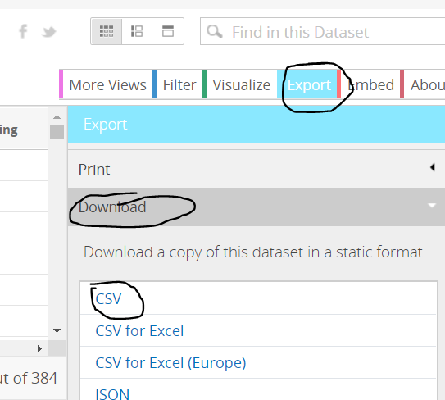
  - Convert file from CSV to XLS and save to appropriate location.
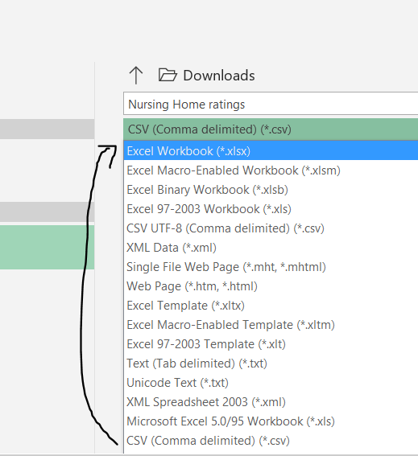

- Organizing Spreadsheet
  - Before using Tableau, we will want to organize our spreadsheet and create separate columns for Latitude and Longitude.
    - Open file and identify column “Location.” Extend column to see each facility’s full addresses and geographic coordinates.
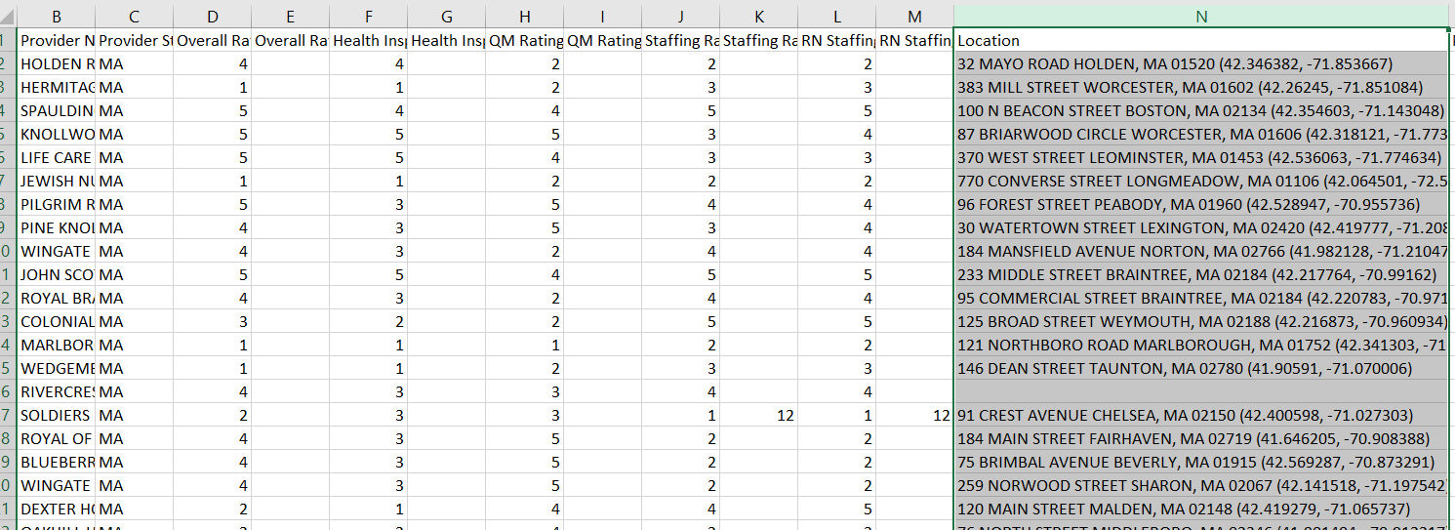
    - Create three new columns to the right of “Location.” Move column labeled “Processing date” three columns to the right. The two empty columns to the right of “Location” will be for Latitude and Longitude.
    - Select Data Text to Columns Delimited Next.
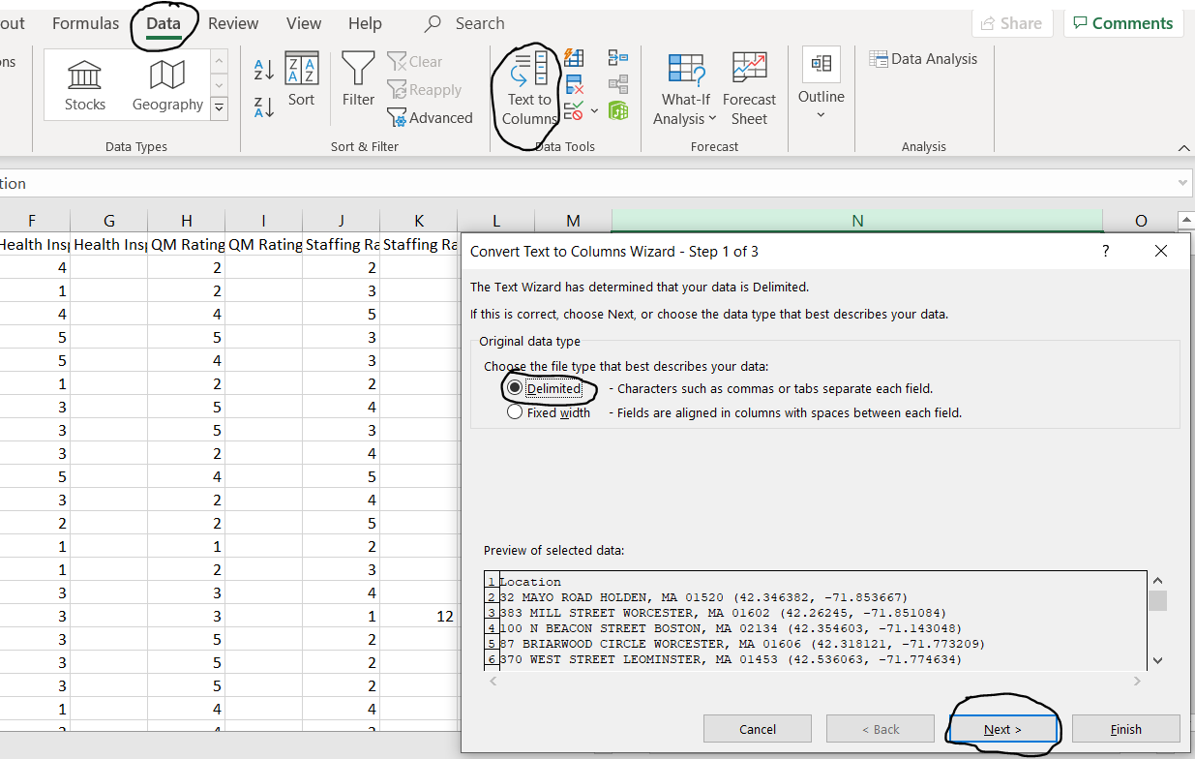
    - On next screen, check “Other,” and type an open parenthesis “(“ and select finish.
The spreadsheet will now display a separate column with the coordinates.
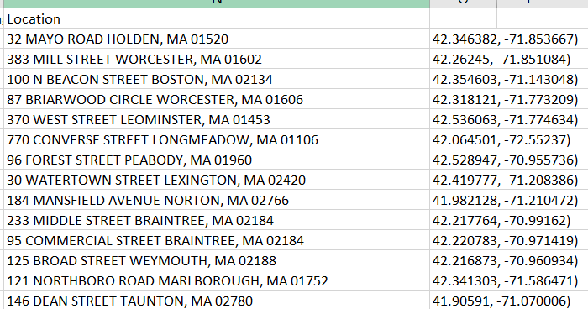
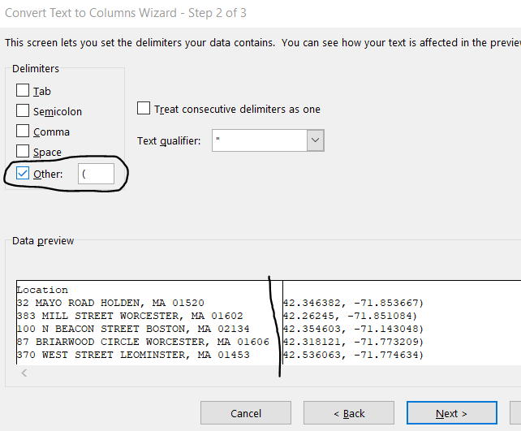

    - Repeat process in 2a-ii to create separate columns for latitude and longitude. With new column highlighted, select Data Text to Columns Delimited Next. On next screen under “Delimiters,” uncheck “Other” and select “Comma.” Then click Finish.
    - Highlight column with longitudinal coordinates and use “find and replace” to eliminate parenthesis “)”. 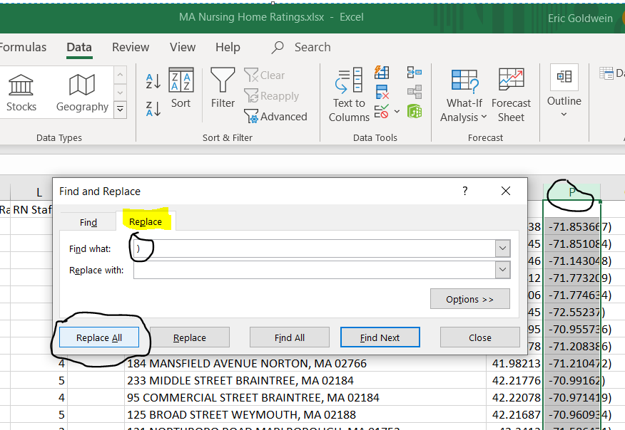
    - Finally, label columns “Latitude” and “Longitude.” Save!

- Finding Missing Coordinates
    - Highlight top row and select filter. This allows you to sort each column.
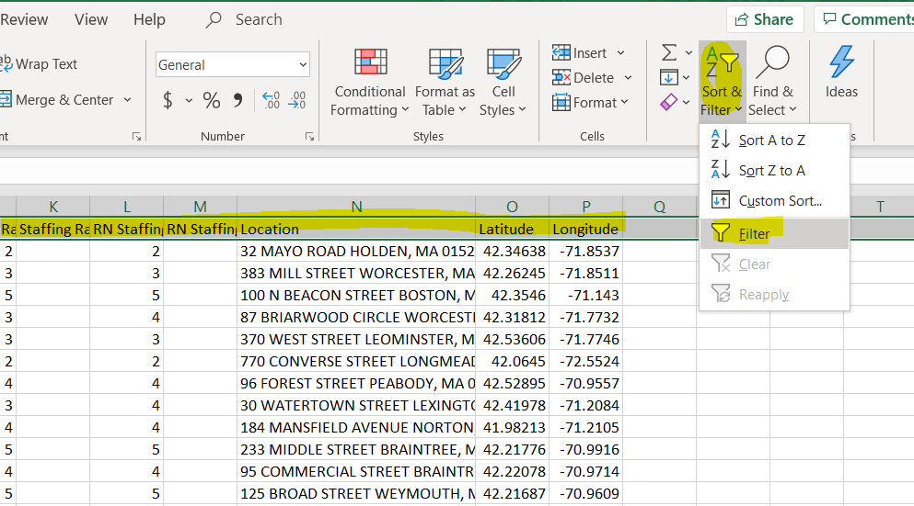D
    - To identify facilities with missing coordinates, sort Latitude or Longitude columns by smallest to largest (or largest to smallest) and scroll down to bottom of dataset.
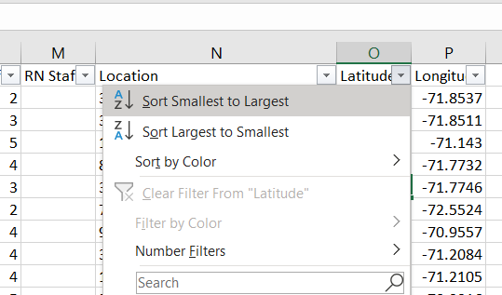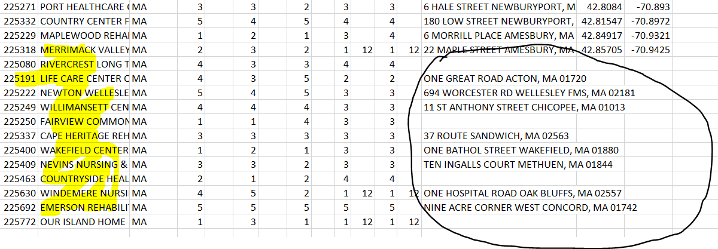
    - To find coordinates, search facility or address on maps.google.com. Find coordinates on URL and paste into excel. Repeat for all missing coordinates. 